“Car Papering System In India”

PROJECT REPORT

Submitted for the course: DATA STRUCTURE AND ALGORITHM (CSE 2003)

By:

OM ASHISH MISHRA-16BCE0789

MAYANK NANDAWANI-15BME00

Slot: G2+TG2

Name of the Faculty: Mr. BHOOMINATHAN P



MAY, 2017

Car Parking System In India

Brute Force Algorithm

Om Ashish Mishra

Student of School of Computer Science and Engneering

Vellore Instistute of Technology, Katpadi Vellore – 623 014

Tamil Nadu, India

[omashish100@gmail.com](mailto:omashish100@gmail.com)

*Abstract*—This document is a “live” template. The various components of your paper [title, text, heads, etc.] are already defined on the style sheet, as illustrated by the portions given in this document. DO NOT USE SPECIAL CHARACTERS, SYMBOLS, OR MATH IN YOUR TITLE OR ABSTRACT. *(Abstract)*

*Index Terms*—linked list, binary tree, queue, parking, counter. *(key words)*

# Introduction

India is facing a new problem nowadays – lack of sufficient parking space. With families getting smaller and the total number of motor vehicles exceeding the total number of heads per family, the parking scenario is woefully falling short of the current requirements in the country. The situation is such that on any given working day approximately 40% of the roads in urban India are taken up for just parking the cars. The problem has been further exacerbated by the fact that nowadays even people from low income group are able to own cars. The number of families with cars has become much more than what the country is able to manage.

As it is, the cities in India are highly congested and on top of that the parked cars claim a lot of space that could otherwise be used in a better way. Thanks to poor, and at times zero, navigability, Indian cities are regarded as some of the worst options for living. One can also add the issue of pollution to this mix and understand the enormity of the crisis. In this context it needs to be understood that the Indian cities, with the possible exception of Chandigarh, were never planned in such a way so as to accommodate a deluge of cars as is the situation now. The apathy of present day urban planners has only made the situation worse.

Om Ashish Mishra

Student of School of Computer Science and Engneering

Vellore Instistute of Technology, Katpadi Vellore – 623 014

Tamil Nadu, India

[omashish100@gmail.com](mailto:omashish100@gmail.com)

# Possible to the menace caring problems

One feels that the authorities who plan the Indian cities should really look into the situation. The public policy needs to be structured in such a way that the issue can be tackled effectively. One way to handle this is to take away the subsidy provided for parking. The charges for parking should be determined as per the land value of the particular area or the rent that is being charged for the same. It is also important that major sites of tourist interest, the heritage zones and shopping areas are made strictly off limit for cars.

However, one feels that it might not be that easy to introduce rules and regulations for parking in India considering the general mentality here is to get all public services for free. However, such rules have to be imposed if the problem is to be solved. If you can buy a car, you should have enough money to pay for its parking charges as well. The policy of politicians to waive off parking fees before elections to garner votes has also left things in the lurch at times. It is felt that if people have to pay parking fees they will feel disinterested from owning a car because of the costs. Cities can be categorised into zones and parking can be charged on the basis of average congestion for that area.

There are some other ways to solve car parking issues, such as multi-level car parking. Multi-level car parking is of two types – conventional and automated. Conventional multi-level car parking can be done anywhere – over the ground or under it. The open parking areas are more preferred as opposed to closed areas in case of parking above the ground as specialized fire protection systems and mechanical ventilation are not needed in this case. Automated multi-level car parking is more difficult to achieve in India considering the fact that it is entirely technology driven and does not involve much human element. As it stands now, India and Indians might not be ready for this technology. The more conventional option seems to be the better bet.

1. ISSUES FACED WHILE PARKING

* ** Inadequate information for motorists** on parking availability and price. Motorists are likely to be frustrated if they expected abundant and free parking but find limited or expensive parking, or if they must spend excessive time searching for a parking space.
*  **Inefficient use of existing parking capacity**. Local zoning ordinances, building codes, and other development practices can result in an oversupply of parking spaces and an inefficient use of existing parking.
*  **Excessive automobile use**. Automobile dependency imposes many costs on society. User costs include reduced travel choices, increased vehicle and residential parking costs, and increased accident risk. External costs include increased road and parking facility costs, congestion, uncompensated accident damages, environmental degradation, negative land use impacts, and reduced mobility for non-drivers.
*  **Economic, environmental and aesthetic impacts of parking facilities**. Businesses ultimately bear the costs of unpriced parking, directly or through taxes that they must pass on to customers. Generous parking requirements can constrain businesses in other

ways.

* ** Parking spaces that are an inconvenience** to nearby residents and businesses. Businesses may experience difficulty in retaining customers and residences may have a problem finding parking close to their homes.
*  **Demand for handicapped parking spaces.** These spaces are generally located, in both garages and surface lots, as close to access ramps and curb cuts as possible.
*  **Impact of additional parking spaces** on area traffic and local residents.
*  **Existing, severe, spillover problems.** When all of the parking demand generated by a certain use (or group of uses) is not being accommodated on the site of those uses or within the adjacent on-street spaces.
*  **Out-of-town parking.** The majority of vehicles parked in a residential area are from outside of the neighborhood. Loading and unloading zones. Scarce parking for commercial vehicles to load or unload will cause them to block travel lanes.
* ** Inconvenient parking options**. Parking within a reasonable walking distance (3 blocks) is hard to find during specific times of the day.
* ** Inadequate pricing methods**. Many require motorists to prepay based on the

maximum amount of time that they may be parked and the price structure used at a

particular parking space. As a result, motorists often end up paying for time they don’t actually use, and if they guess wrong they face a fine.

*  **Confusing parking policies**. Regulations and fees may apply at certain times but not others. Parking subsidies may be provided to some users but not others.
* ** Difficulties with parking regulation and pricing.** This problem can cause problems, including traffic congestion as motorist cruise for parking or stop in a traffic lane to wait for a space, and parking congestion in nearby areas.
*  **Lack of sufficient parking at event site**. Special events can potentially disrupt traffic flow and require crowd management. Each event can generate its own unique transportation issues.
*  **Low parking turnover rate.** This can occur when cars are parked in the same space for at least 4 hours (on average).

1. PARKING MANAGEMENT OPTIONS

The following recommendations outline several parking solutions to consider in order to create a parking management system capable of solving existing and future problems.

*  **Prioritizing funds**. Devoting land and funds to automobile parking often reduces the resources available to support other non-auto modes. As a result, policies that increase parking supply tend to reduce overall transportation choices.
*  **Consider long-term commuter parking needs versus short-term**. A functional and financial analysis of constructing a parking garage or long term surface lot would yield important information for the area as it plans for new development rather than solving the existing condition.
*  **Improve information for motorists**. Create signs, brochures and other information resources indicating parking availability and price.
* ** Reduce automobile dependency and encourage transportation alternatives**. Improve availability and accessibility of public transport including bus stops and discounted bus fares.
*  **Increase the range of parking convenience and price levels available to consumers.** Strengthen parking enforcement by developing more convenient payment and time options.
*  **Share parking facilities**. Parking can be shared among different business in an area to take advantage of different peak periods. Encourage businesses to share parking. For example, businesses with no night-time hours can make their parking available for those that have night-time hours.
*  **Park once and walk**. Focused on centralized, shared parking that will create a “park once, then walk” environment. This is the key in promoting businesses in cities, particularly within central business districts which allows multiple users to reach multiple destinations.
* ** Mixed-use parking**. Require shared parking in mixed-use developments and in mixed use areas, since peak demand periods occur at different times. For instance, churches often address their parking needs by sharing parking with nearby commercial establishments since most churches co-exist with single-family residences and commercial structures. This works well because religious and commercial uses typically have peak parking at different times.
*  **Explore opportunities to make greater use of remote parking locations and shuttle services**. The objective is to have a bus system that would transport a group of people from a remote parking structure to their destination. A great example of this is the partnership between a zoo and a shopping mall. During the mall’s peak shopping seasons, shoppers have the option to park their cars at the zoo and take the shuttle provided by the shopping mall to the stores.
* ** Provide shuttle services to parking facilities**. In some situations (airports, large entertainment centers, and large commercial centers), shuttle buses may allow longer distances between parking facilities and destinations.
*  **Advertise shuttle services**. It is important to publicizing shuttle services by posting onbthe Internet, on other nearby community buses and through media targeted to the userbgroups.
* ** Foster coordination and cooperation with businesses, residents, and otherbgovernmental agencies to address parking needs.** Obtain participation from businesses and parking management companies with the validation approach where people generally receive either a reduced rate for parking or free parking for a specified time. This option is attractive when the demand is in off-peak parking hours.
*  **Address spillover parking problems**. This difficulty can be addressed by pricing, regulation, and enforcement in areas that experience such problems and compensation to residents who bear negative impacts. In some instances, good neighbor efforts are used. For example, in some communities, residents near high schools and colleges are given free tickets to sport events to compensate for spillover parking problems that occur during such events.
* ** Preferential residential parking zones**. To ensure those residents and their visitors will have a place to park in certain neighborhoods, cities may permit the establishment of a preferential parking zone. This limits the length of time vehicles may be parked onstreet, unless a valid residential permit is displayed.
*  **Promote preferential parking for carpools and vanpools**. This provides an inexpensive way to encourage High Occupancy Vehicle commuting and it can reduce the need for employee parking.
*  **Residential parking permit ordinance**. Residential neighborhoods with documented problems from parking that “spill-over” nearby non-residential activity centers. The residential permit parking ordinance prohibits on-street parking generally for more than two or three hours during varying time periods. The City posts signs in each block of the parking districts describing the time limits and hours of enforcement. Vehicles displaying the appropriate parking permits are exempt from these restrictions.
*  **Manage residential on-street parking**. This can be applied by setting permit prices to reflect demand and available curb space, or limit the number of new residential parking permits.
*  **General parking restrictions**. No permits are issued. This works well for spillovers. No permits are issued. All vehicles, including residential are not allowed to park on the street.
*  **Zone system**. An example of this approach is to limit parking to 2 hours. It established to discourage “sleeper parking” a common practice of downtown employees who shuffled their cars between 2 hour spaces and to free up parking for visitors.
*  **Valet parking**. The benefit of providing valet parking is to improve business by reducing the number of cars driving around looking for a space. Also up to twice as many cars can fit into a lot when valet services are used.
*  **Establish Traffic Management Associations**. This group offers parking brokerage services so that facilities with excess parking capacity can seek, lease or trade it to others. This allows all building owners to benefit from flexible parking requirements, not just developers of new facilities.
*  **Clustering parking**. This layout can reduce the number of driveways onto arterials and can further improve traffic flow and safety, and create more accessible land use patterns.
*  **Transit Oriented Districts**. Parking policies that encourage higher-density, clustered development create more accessible land use, which supports walking, cycling and public transit use. Some companies offer bicycle parking showers, financial incentives to use transit, and provides a mid-day shuttle for their employees.
*  **Location of parking lots**. Locating buildings close to the street, with parking facilities behind, can help create a more accessible, pedestrian-friendly streetscape. Parking facilities located in front of a building tend to reduce pedestrian access compared with buildings located close to the street with parking located in the back.
* ** Seek a balance between providing sufficient parking, minimizing the amount of land used for parking lots and improving appearance.** Many parking lots designs result in far more spaces than actually required. By implementing a “green” parking lot concept, parking guidelines will set maximums for the number of parking lots created, minimizing the dimensions of parking lot spaces. Utilizing alternative pavers in overflow parking areas can improve the visual aspects of parking lots particularly near residential areas.
*  **Parking space comparison**. A larger number of small parking spaces are more useful and attractive than fewer, larger parking facilities.
*  **Encourage use of intelligent parking systems.** Advanced Parking Systems (APS) obtain information about available parking spaces, process it and then present it to drivers by means of variable message signs. APS is used in two ways: to guide drivers in congested areas to the nearest parking facility with empty parking spaces and to guide drivers within parking facilities to empty spaces.
*  **Locate parking**. This theory takes a look at strategic intercept points to minimize driving into and through central areas of the community.
*  **Ensure sufficient handicapped parking to meet existing needs and regulations**. Parking facilities that reflect Universal Design principles with features that make parking facilities better to accommodate people with special needs, with handicapped parking spaces and circulation paths designed for wheelchairs can better accommodate people with disabilities.
* ** “Cashing Out” the value of parking**. Encourage employers to participate in this program to fully or partially subsidize parking offer workers the option to give up their parking space in exchange for its monetary value.
* ** Transit-rich area**. In walkable, transit-rich neighborhoods, eliminate minimum zoning requirements for parking to encourage non-auto travel.
*  **Paid parking**. Some attractive, livable cities have very limited and expensive parking. It is a costly and inconvenient to drive and mobility is achieved through convenient and ubiquitous transit.
* ** Pricing strategies**. This approach discourages long-term use of off-street parking in order to make spaces available for customers of a business district.
*  **Meter options**. Use parking meters to optimize turnover of spaces for priority users. Raise meter prices to reflect the market demand. Charge for curb space during peak hours, e.g. night time entertainment districts would require meter charges during peak night time hours.
*  **Load/unload zones**. For businesses with quick turnarounds (banks, dry cleaners) and delivery needs. Usually these zones have a 30-minute time limit.
* ** Replace surface parking lots with subterranean ones**. More costly but they free up land and convenient and close-in parking.
*  **Zoning requirements for new development**. Use zoning as a tool to encourage new development to be more pedestrian friendly. Neighborhood commercial zones define pedestrian-oriented shopping or mixed-use areas, and discourage the placement of parking between the building and the street.
* ** Modify the zoning requirements**. Most codes require developers and employers to provide a certain number of parking spaces for every built square foot of space. Local government can amend parking requirements to limit, rather than require a minimum number of parking spaces per floor area or employee.
*  **Annual review**. Periodic evaluation of parking related ordinances should occur to align current parking practices and enforcement with City policy.
*  **Parking enforcement coordination**. Coordinate parking enforcement activities among all City Departments including Transportation, Police, and Public Works
*  **On-street parking**. Useful resource in business districts or on adjacent streets in residential areas where adequate parking exists.
* **Signed parking restrictions**. Encourage short-term parking and turnover, and loading/unloading. Changes are generally at the request of adjacent business and property owners.
* **Metered parking**. Mainly used in commercial areas with the support of business and property owners. Meters encourage short-term parking access and availability, and turnover that businesses value.
* **Angled parking**. Can increase overall supply of on-street parking, if the street is wide enough.
* ** Off-street parking**. The amount of parking for commercial uses is based on the type of use and assumptions about the parking demand it generates (short-term, handicapped, carpool/vanpool spaces).
* These proposals should be applied fairly and do not single out certain property owners.
* Do not make development regulations unduly complex or substantially raise the cost of development or housing.

1. WHAT HAPPENS IN ADVANCED CONTRIES?

In the First World areas such as Europe people need to get to an area of tourist attraction either on foot or by using a mode of public transport. It is not like in India where people can drive to any such place in their cars and clog up the surrounding area with their private vehicles. In a developed country, which is among the prominent manufacturers of cars, not many people own cars. The reason for this is that a car license is really expensive and people who want one also need to prove that they have sufficient parking space in offices as well as their homes. It also helps that public transport is of the highest order in these regions with monorails, meglevs, metros and high speed trains for example.

As is the case with majority of the other public services in India, accountability has to be the key over here as well. The policies can be made but the people have to obey them properly and make them successful. Also, the authorities need to understand that restricting access to car ownership will only be a short term solution. For the longer term solution, proper planning needs to be done. The state of public transport in India needs to be improved. Unless and until the modes of public transport are not plentifully available, people will keep on relying on cars and the problem will never be solved.

1. THE PROGRAM:

# Acknowledgment

I would like to extend our sincere gratitude to Mr. BHOOMINATHAN P for his continued support, inputs, and guidance. The combined team work helped us in achieving our objective and renders our project successful.

Also, I would like to thank the management of VIT University and to the Dean of SSL, for

providing us with this wonderful opportunity to learn new things, and to expand our horizons, through the ample amount of facilities and opportunities available here in VIT University.

# References

For my research and need these papers, journals, articles helped me a lot. Some of them are Indian issues and sinarios and others are from foreign authors .

1. [www.mapsofindia.com/my-india/.../parking-problems-in-india-and-their-solutions](http://www.mapsofindia.com/my-india/.../parking-problems-in-india-and-their-solutions).

[2] International Journal of Electrical and Electronics Research ISSN 2348-6988 (online) Vol. 3, Issue 4, pp: (121-124), Month: October - December 2015, Available at: [www.researchpublish.com](http://www.researchpublish.com)

[3] An Overview of Common Parking Issues, Parking Management Options, And Creative Solutions prepared for City of Pasadena, Department of Transportation. Report prepared by Banerjee & Associates.

[4] <http://indianexpress.com/article/cities/chandigarh/parking-problems-on-the-rise-proposals-for-solutions-gather-dust/>

[5] [www.happiestminds.com/whitepapers/smart-parking.pdf](http://www.happiestminds.com/whitepapers/smart-parking.pdf)

[6] <http://timesofindia.indiatimes.com/city/delhi/Delhi-is-worst-place-to-park-inwont-get> better/articleshow/49019295.cms

[7] Journal of Engineering Research and Studies E-ISSN0976-7916 JERS/Vol. III/ Issue II/April-June, 2012/67-71 Research Paper OFFSTREET PARKING MANAGEMENT PLAN FOR DHARWAD CITY, KARNATAKA, INDIA Mrs Priyanka. Kolhar Address for Correspondence Asst Professor, Dept of civil engineering, RV College of Engineering, Bangalore, Karnataka, India.

[8]AjaiSreevastan, Will Parking get Dearer? The Hindu, 25.10.2011

[9] Banerjee, S, Government Flout parking rules at Kolkata Airport, Hindustan Times, 12.8.2013

[10] Dewan, K K, M Mustafa and PunitaSaxena, Car Parking: Managerial Perspectives (A Case Study of Delhi), Indian 4)Journal of Transport Management, Vol.25 (6), OctoberDecember, 2001

[11] Arnott, R and J Rowse, Modelling Parking, Journal of Urban Economics, Vol-45, 1999

[12] Government of India, National Urban Transport Policy, Ministry of Urban Development, New Delhi, 2005

[13] Centre for Science and Environment: Citizen‟s ReportAir Quality and Mobility in Kolkata, 2001

[14] AjaiSreevastan, Times to Boost Public Transport in a Big Way, The Hindu, 5.7.2011

[15] Government of India, Study on Traffic and Transportation Policies and Strategies in Urban area in India, Ministry of Urban Development, New Delhi, 2008.

[16] Young, W, and M Taylor, a Parking Model Hierarchy, Transportation, No. 18, 1991

[17]Gillen D W, Parking Policy, Parking Location Decision and Distribution of Congestion, Transportation, 7, 1978

[18]Institute of Highways and Transportation, 2005: “Parking strategies and Management”

[19]Singh, S K, Review of Urban Transportation in India, Journal of Public Transportation, Vol 8 (1), 2005

[20]Jayapal, P and K Srirangan, Parking Management in Delhi – Emerging Imperatives, Urban Transport Journal, Vol.1, No. 2, December, 2000

[21]Kolkata Municipal Corporation Lens on Illegal Parking Lots, The Times of India, 17.01.2013

[22]Patankar, P, Urban Transport in India in Distress, Central Institute of Road Transport, Pune,1991

[22]Young, W, Thompson RG and Taylor MAP, Modelling and Parking Policy Formulation, Transport Reviews, Vol.11 (1), 1991.

Flowchart

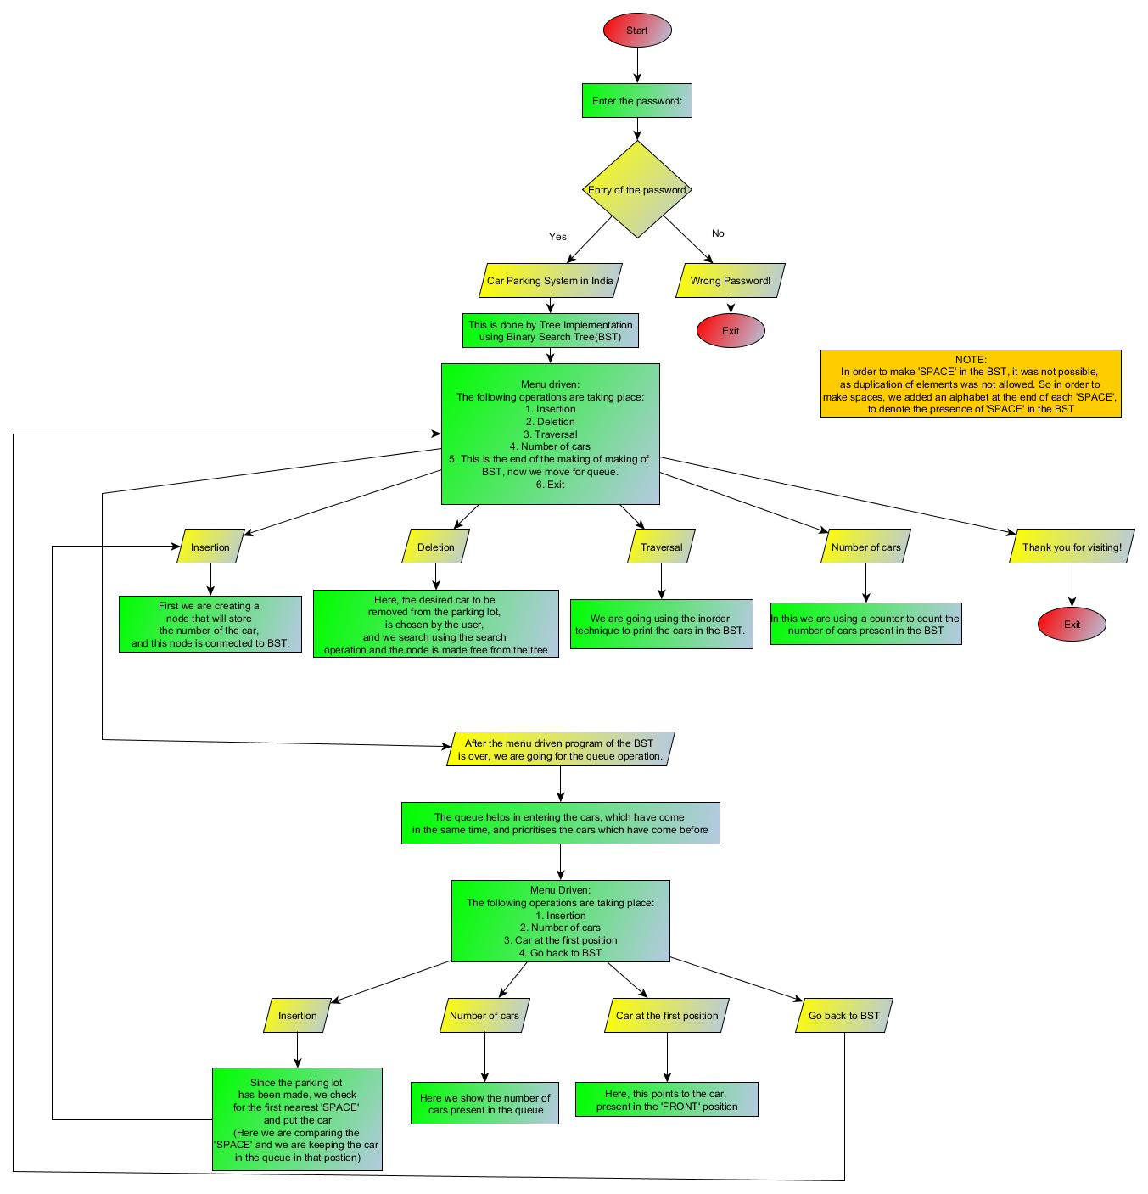

Our Program

The Header Files

* #include <stdio.h>
* #include <stdlib.h>
* #include<string.h>
* #include<conio.h>
* #include<windows.h>

The Binary Search Tree for Parking lot

* struct Parking

{

char value[100]; //Value of the car number

struct Parking* l; //Left pointer of the tree

struct Parking* r; //Right pointer of the tree

* }*root = NULL,*temp = NULL,*t2,*t1;

Pointers of the tree

* **Root** is the starting point of the tree and temp is a temporary pointer the tree to continue.
* **Pointers t1 and t2** are used for
* **t1** is used to delete or find leaf node with 0 children or 1 child(left or right)
* **t2** is used to delete 2 children in the tree and for finding smallest and largest element in tree

Functions of the tree

* **void insert():** To insert a node into the tree
* **void create():** To create a node
* **void search(struct Parking*t):** To search for another node position if the root node is present
* **void display(struct Parking*t):** For traversal of the nodes
* **void delete():** To delete a node form the tree
* **void search1(struct Parking*t,int data):** To search for the position of the desired root to be deleted
* **void delete1(struct Parking*t):** To delete the node it can be of 0,1 or 2 children
* **int smallest(struct Parking*t):** To calculate the smallest node on the left
* **int largest(struct Parking*t):** To calculate the largest node on the right
* **void count_Cars():** To count the number of cars present in the Parking Lot

Queue for waiting cars outside the Parking Lot

* struct node
* {
* char info[100];
* struct node *ptr;
* }*front,*rear,*TEMP,*front1;

The pointers of the queue:

* The **front pointer** represents the car at the starting of the queue.
* The **rear pointer** represents the car at the end of the queue.
* **TEMP** is the pointer used to make.
* The **front1** is used for dequeuing cars.

The functions of queue

* void frontelement(): The car present at the first position in the queue
* void enq(char data[100]): The insertion of the cars in the queue
* void deq(): The deletion of the cars in the queue
* void empty(): Checking for the queue is empty or not
* void searching1(char data): To insert car into the tree from the queue
* void create11(): To start the queue Linked list
* void queuesize(): To see the number of cars present in the queue

Global Variables:

* int flag=1,i;
* int c=0,k = 97,k1=1,k11=1,h=0;
* int qs=0;
* int j=0;
* int count = 0;
* char s[100],s1[100];
* char e[100],f[10];

**THE OUTPUT**:

Wrong password!!



Correct password



Insertion into Binary search tree

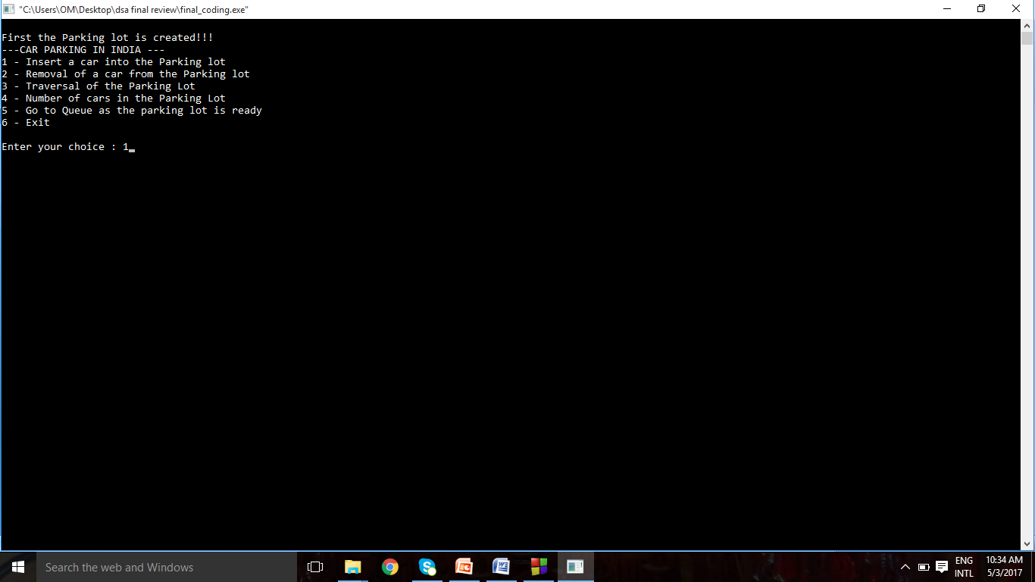

The car inserted



Again car insertion removal of cars (deletion):

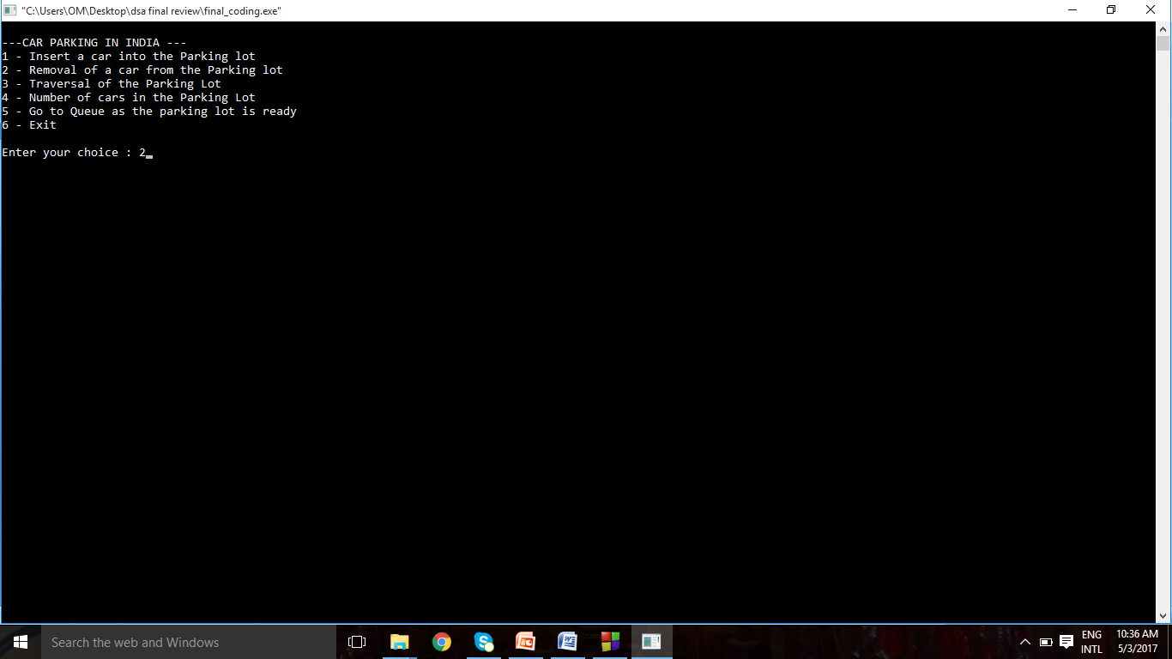

Car to be delected



Traversal

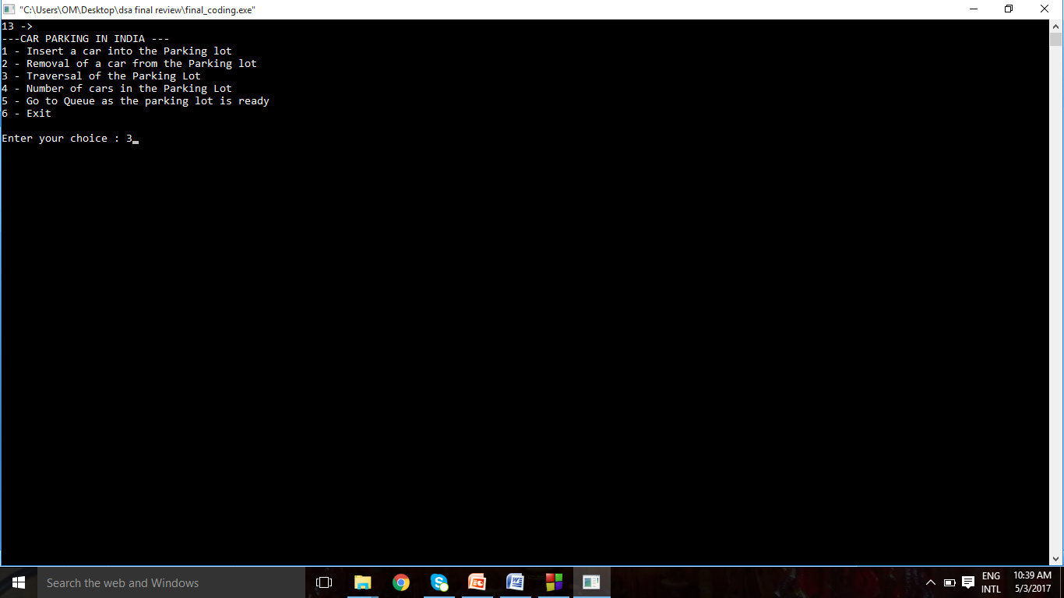

The number of cars in the parking lot

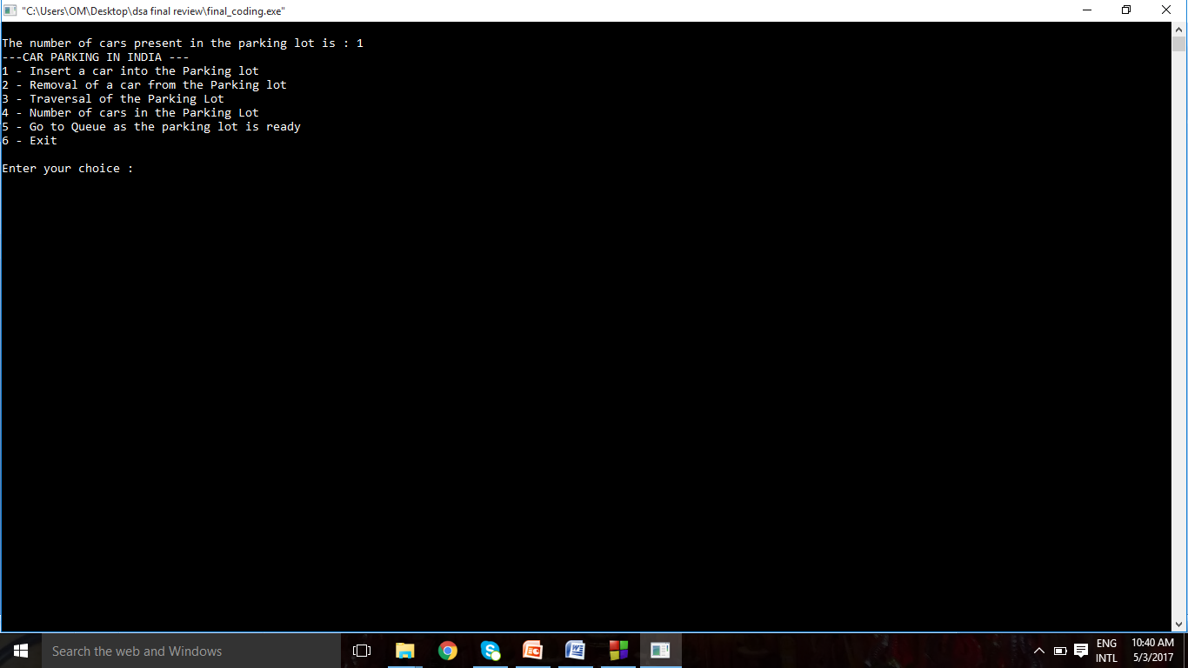

Creating space for in the parking lot insertion of space



Traversal

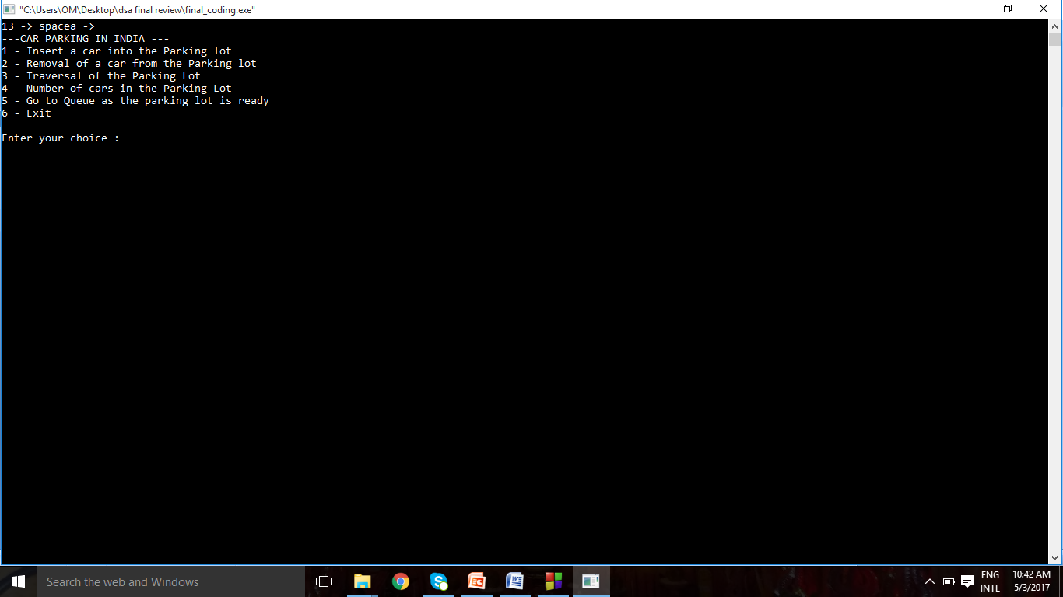

Now going for queue

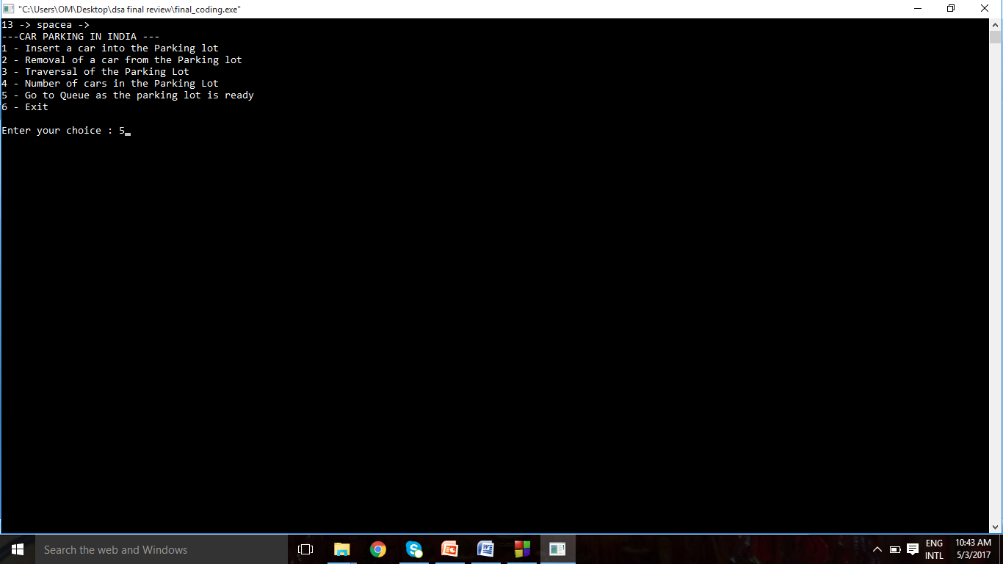

Insertion by queue

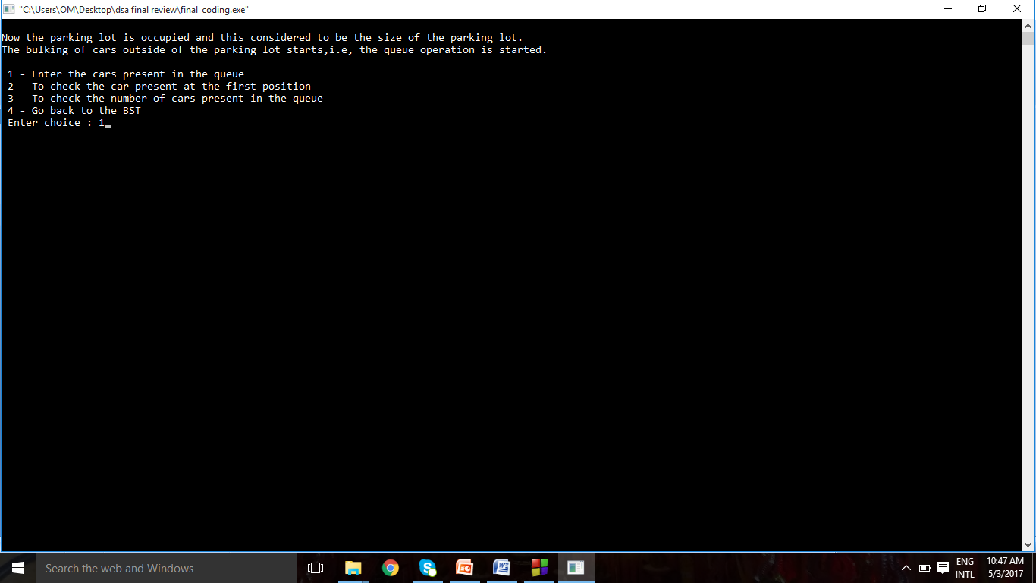

Insertion in queue and binary search tree



To check the car in front position

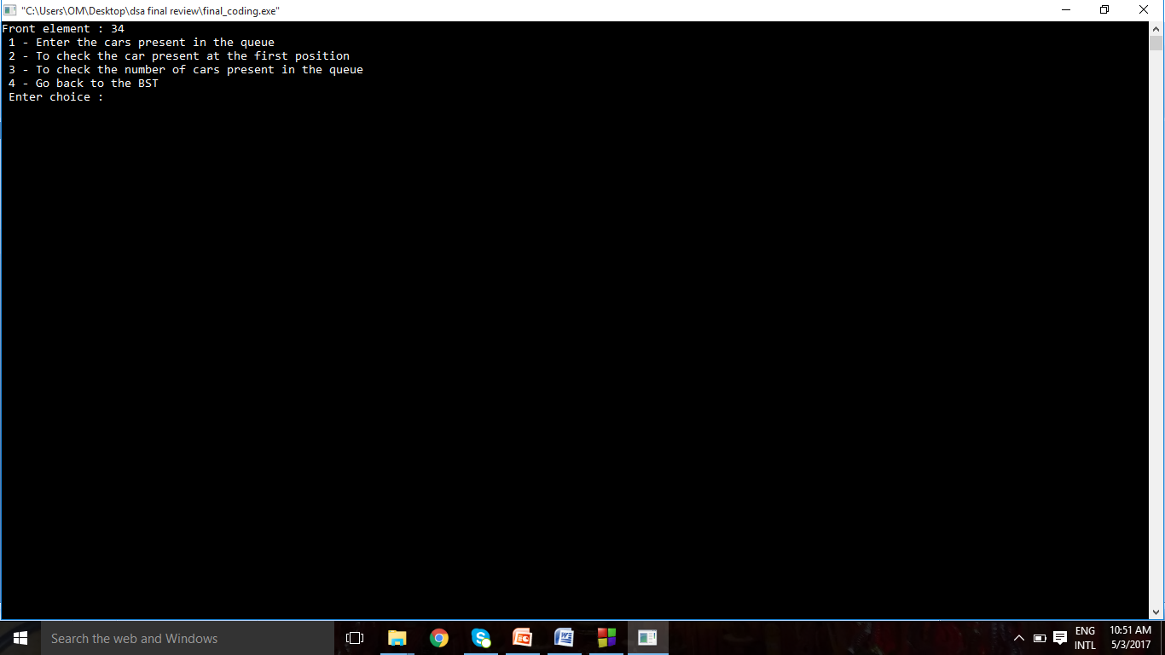

Checking the size of queue

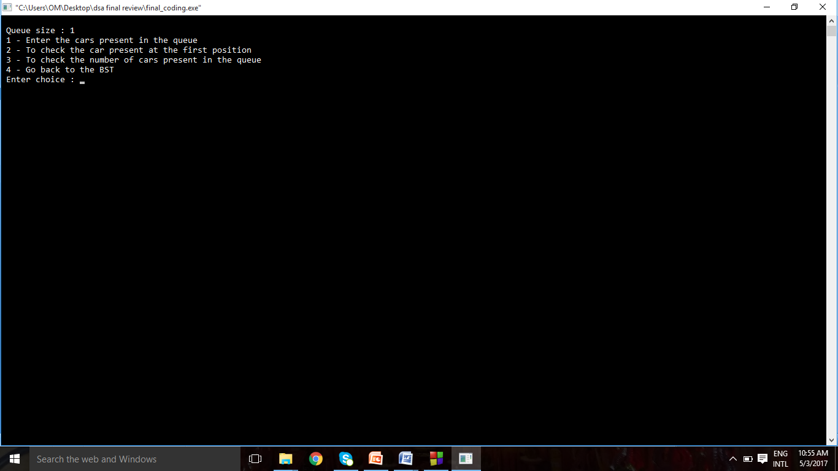

Going back to tree

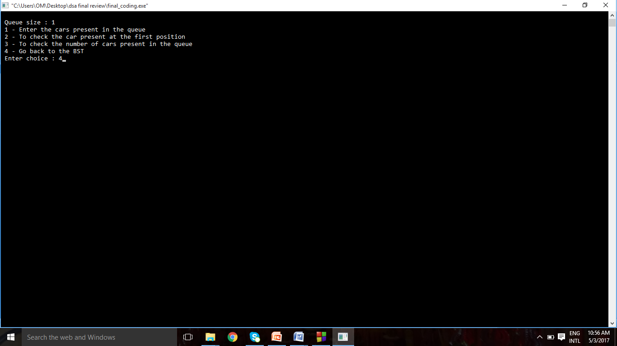

Queue is freed

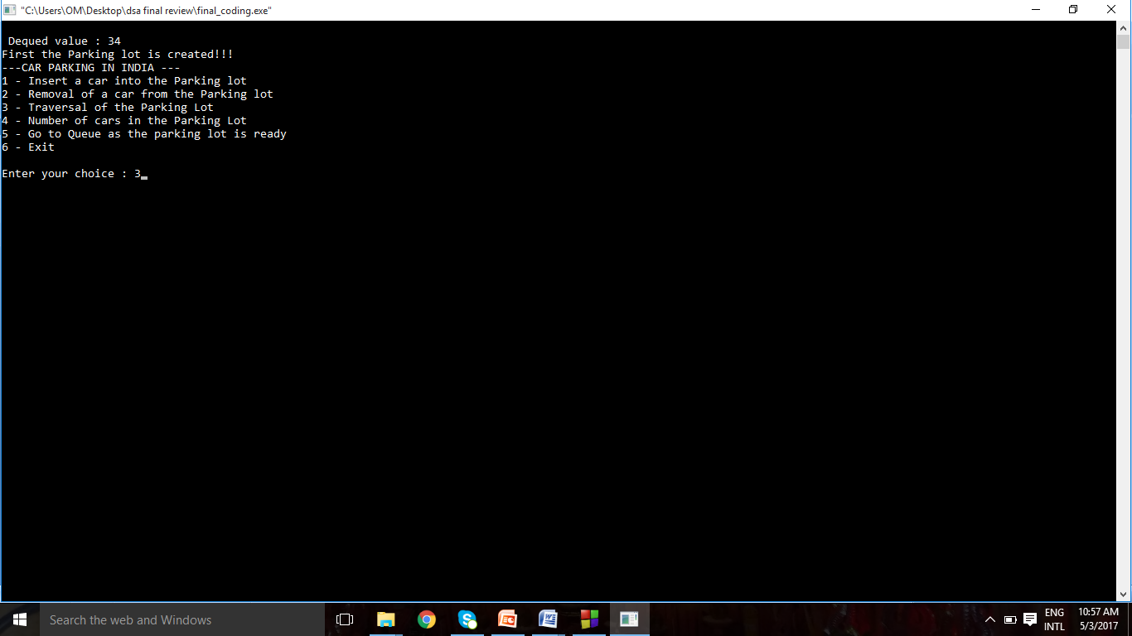

Traversal

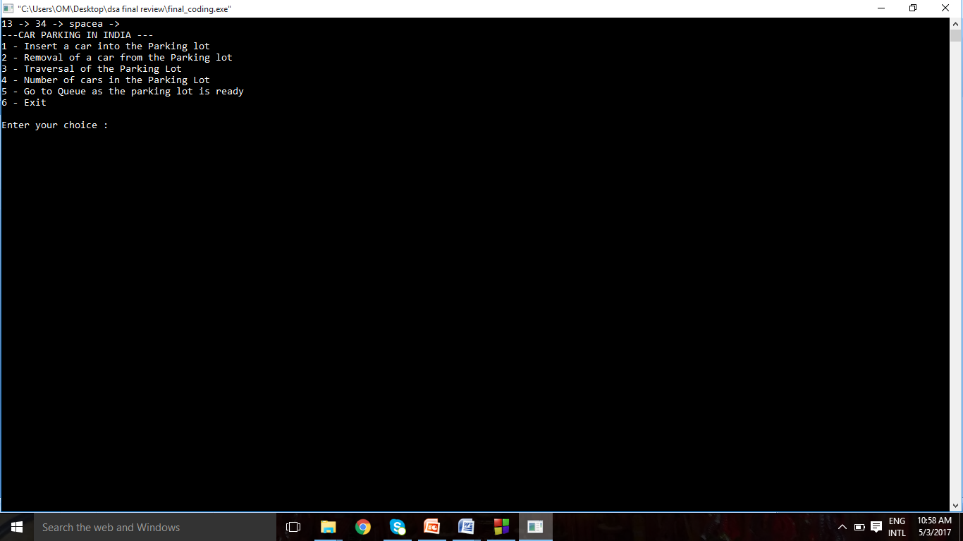

Deletion



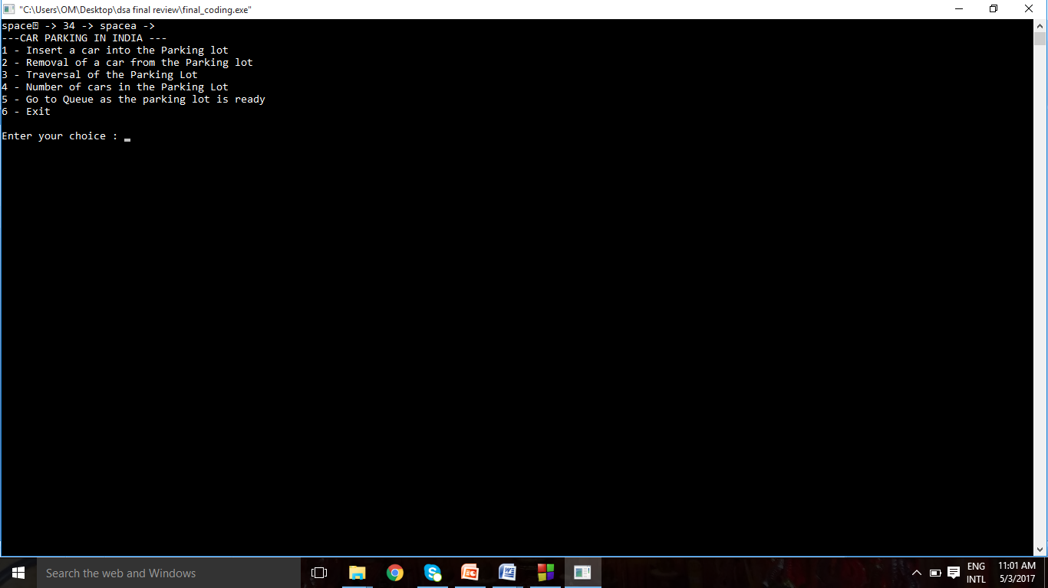

Insertion

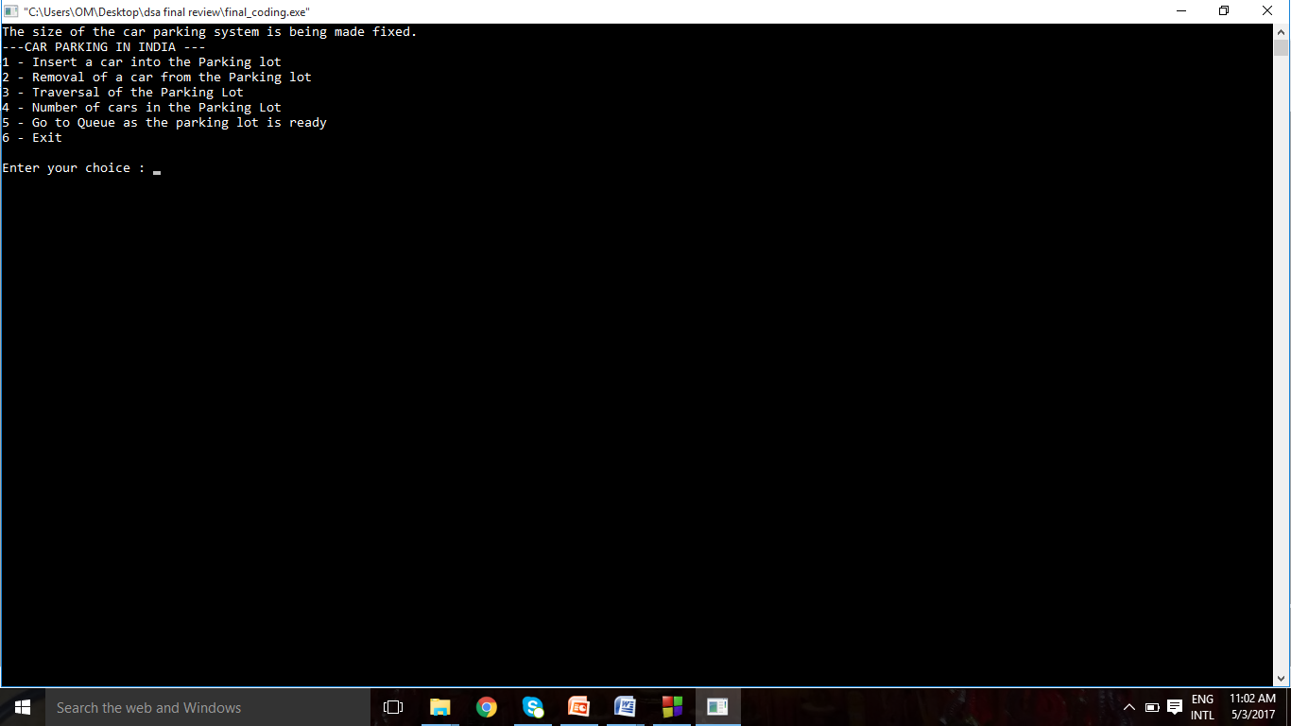

Exit form program

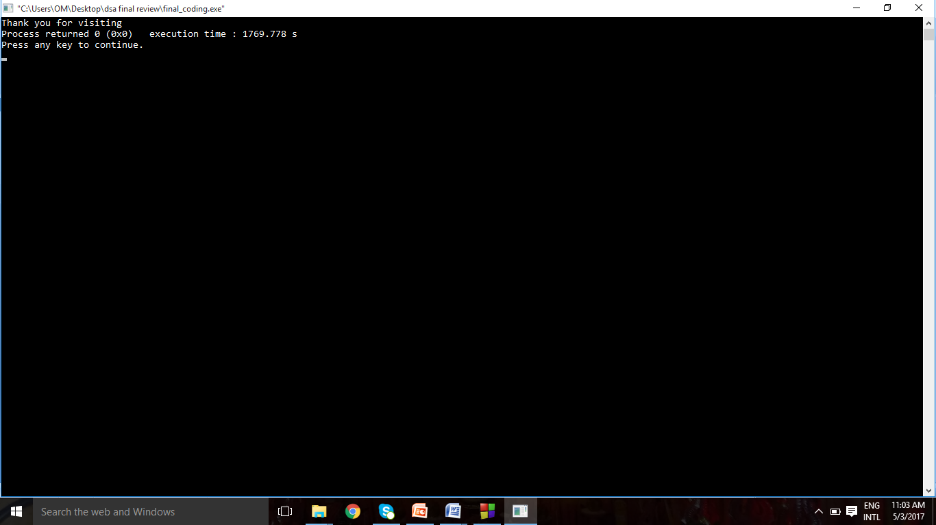

THANK YOU